**LinkedIn Sharing**

**LinkedIn App:**

Create LinkedIn App to use LinkedIn features like: posts.

**Steps:**

1. Create Twitter Application here: <https://www.linkedin.com/developers/apps> with following settings:

E.g.:

App name => SocialSharing

LinkedIn Page=> <https://www.linkedin.com/company/socialsharingtest> (Live Company Link for Prod)

Authorized redirect URLs => <https://localhost:44300/Home/SocialSharing> (Live Url for Prod)

Privacy policy URL=> <http://gmail.com/> (Live Url for Prod)

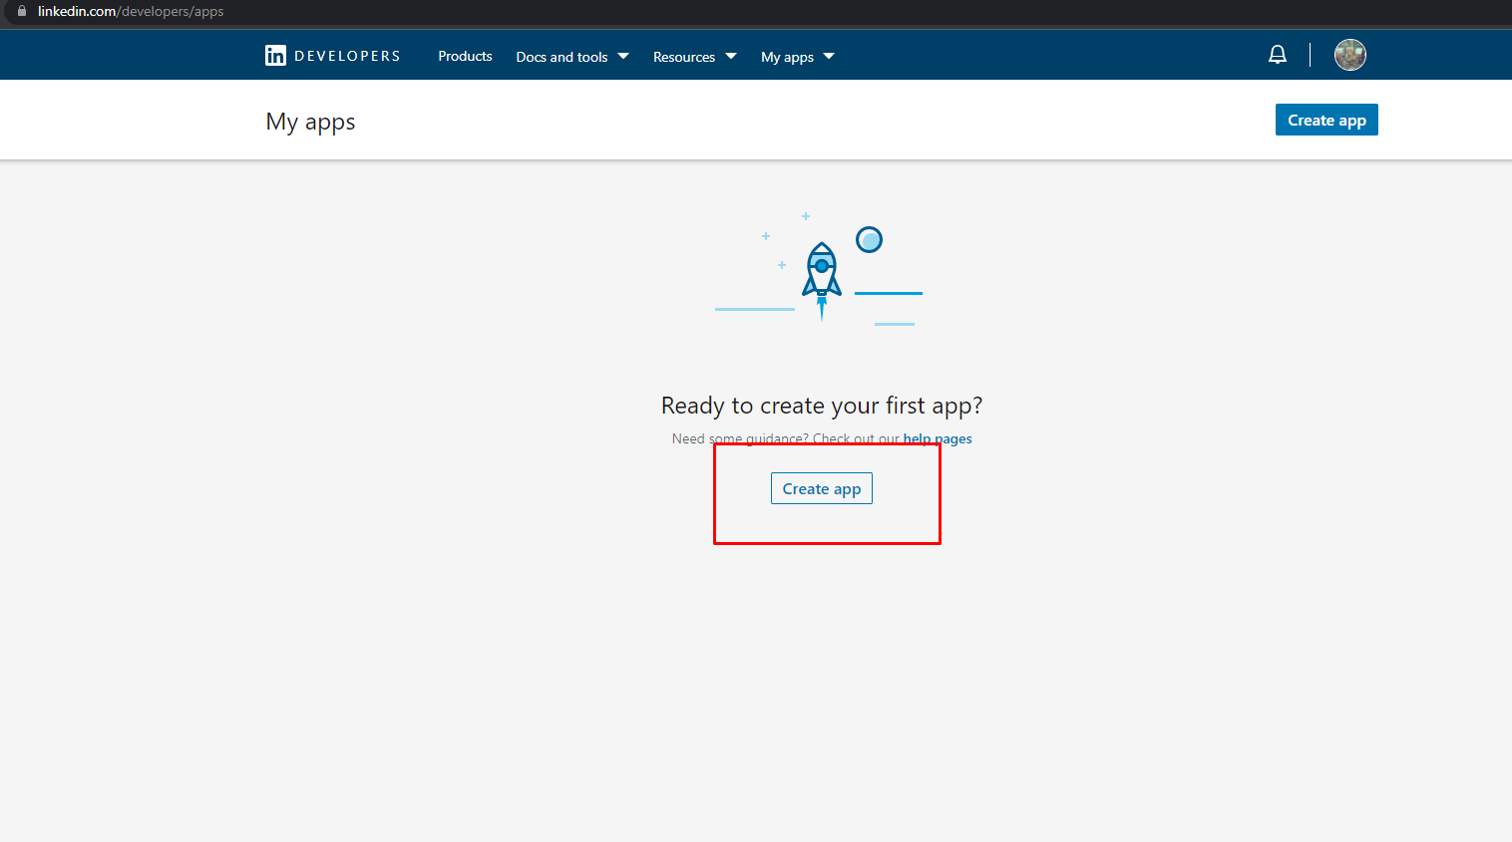

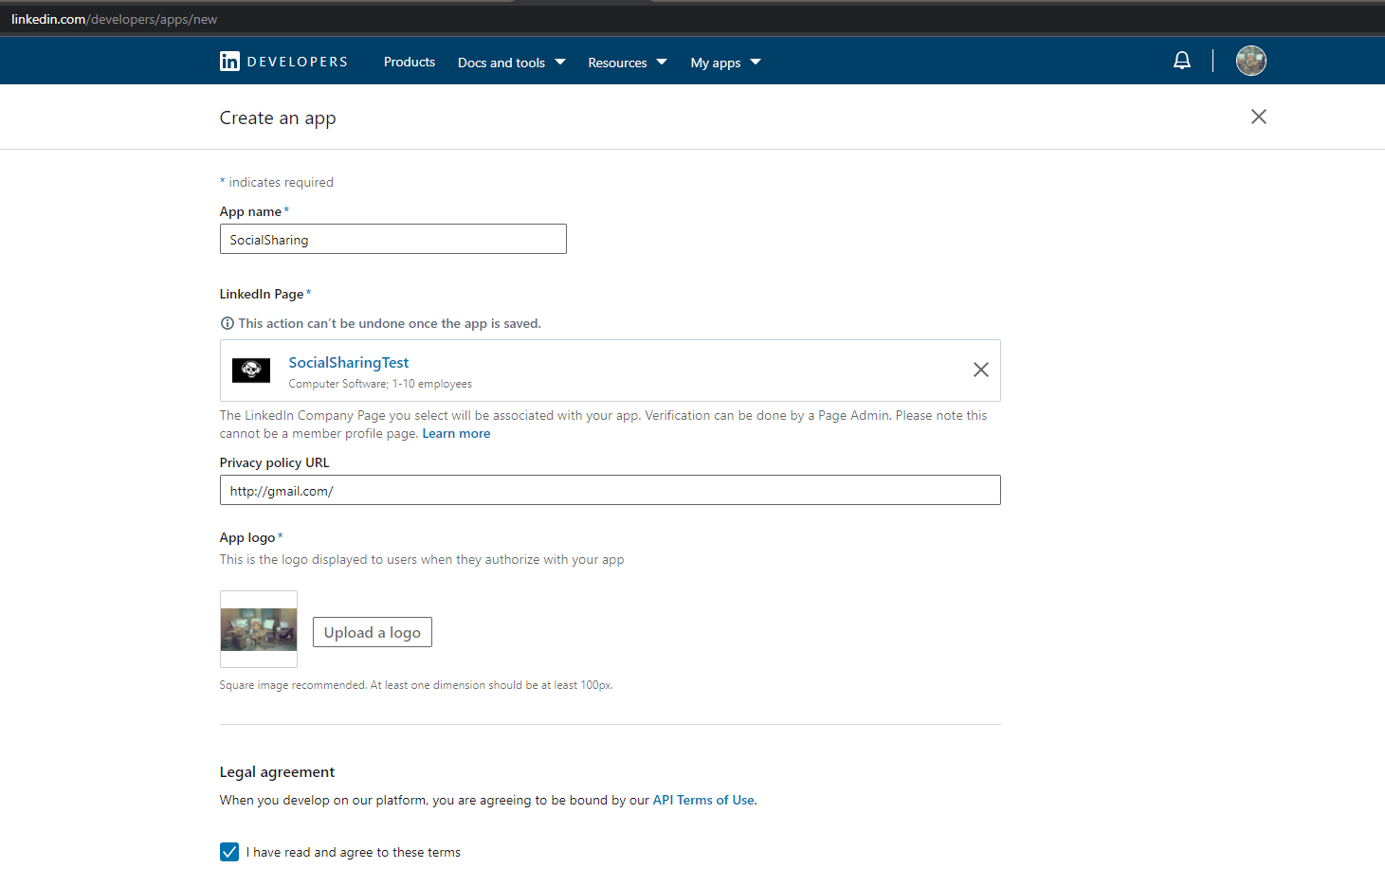

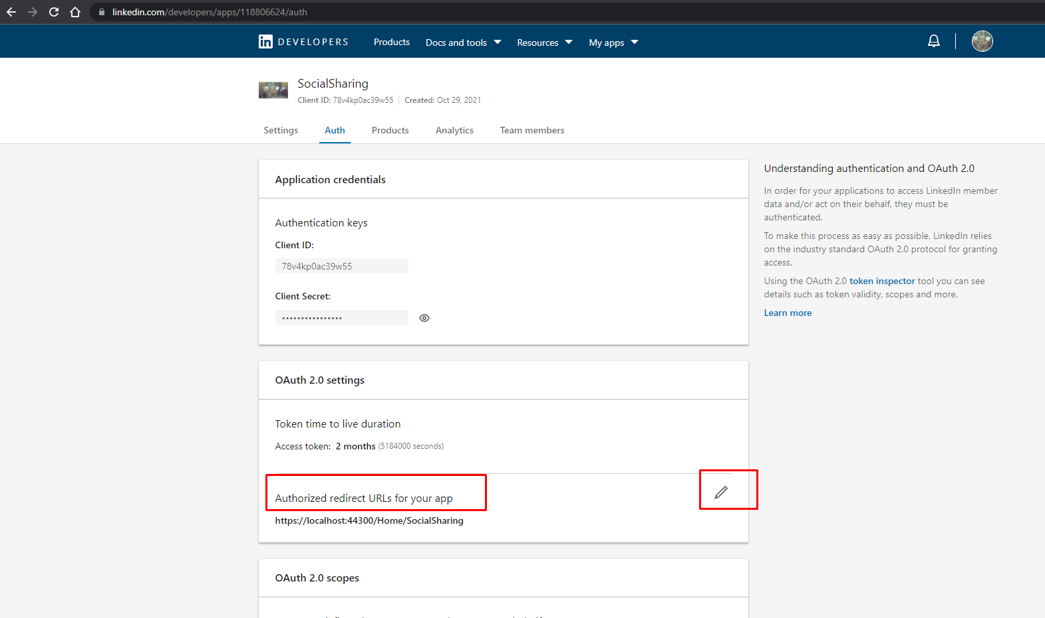

1. Add “Share On LinkedIn” and “Sign In With LinkedIn” Product by navigating to Products tab.

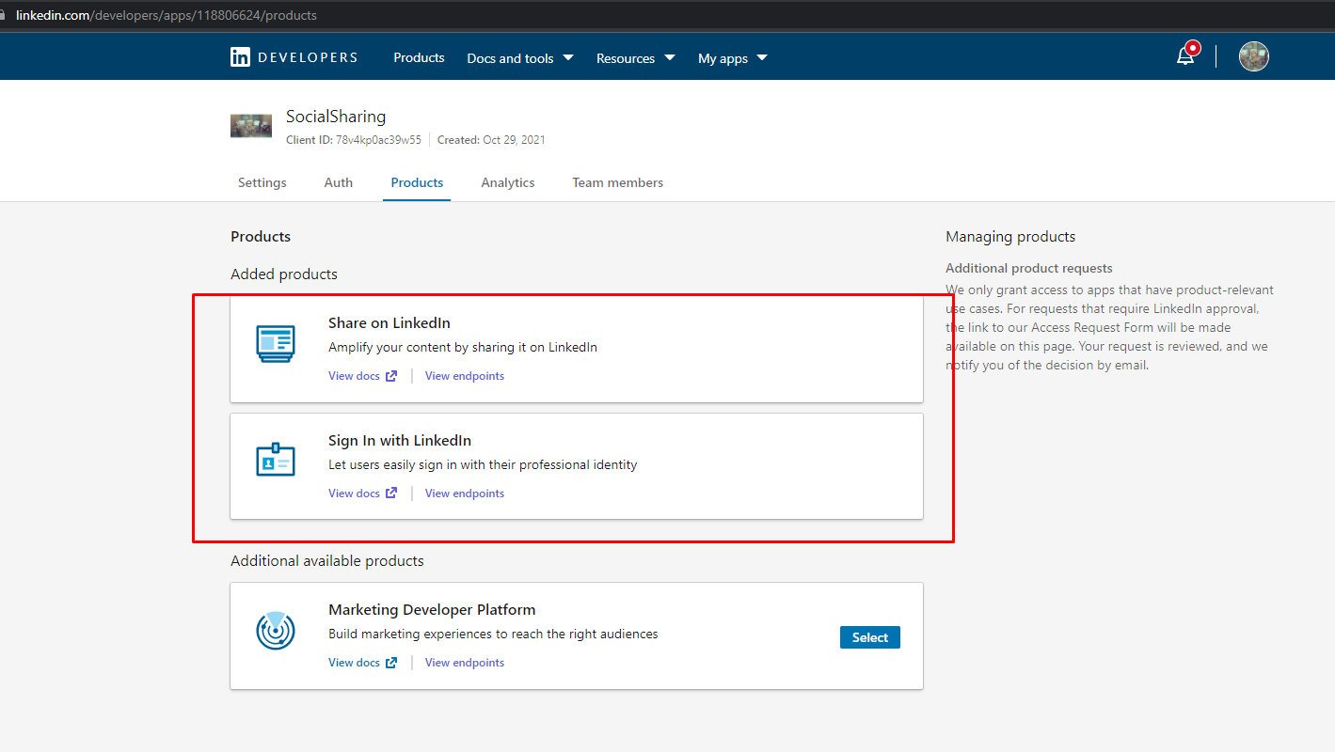

**Keys and tokens:**

Generate keys and tokens for authentication.

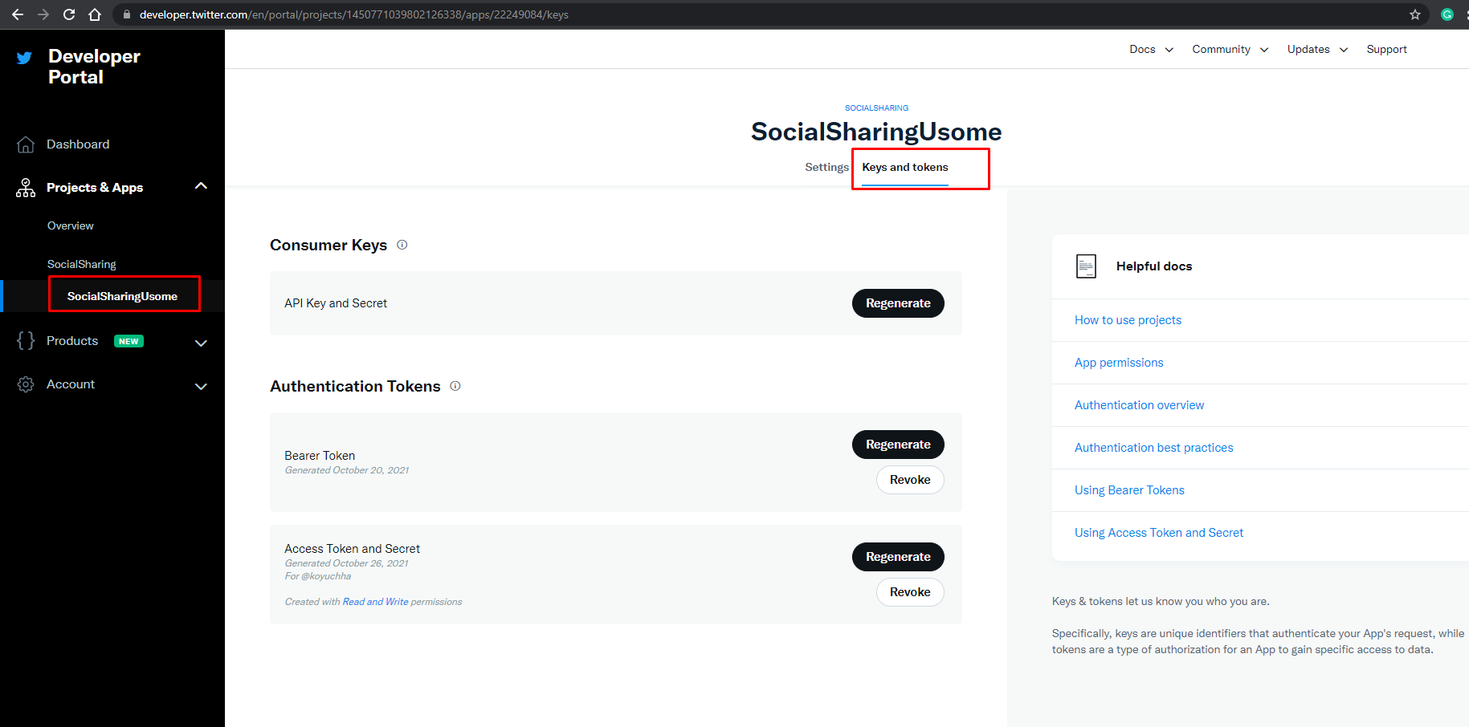

**References:**

Package/SDK : CoreTweet (<https://coretweet.github.io/)>

Twitter Doc:

<https://docs.microsoft.com/en-us/windows/communitytoolkit/services/linkedin>

<https://docs.microsoft.com/en-us/linkedin/shared/authentication/authorization-code-flow?tabs=HTTPS>